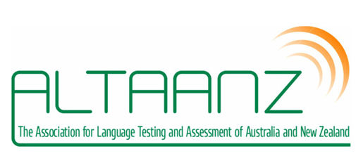
Call for proposals: ALTAANZ Sponsorship for Professional Development Activities
ALTAANZ is offering sponsorship in 2023 for two professional development activities for ALTAANZ members. A professional development activity is aimed at developing skills and knowledge in language assessment and testing. Activities can be in the form of a workshop, a seminar, a lecture, or another activity type. Activities should align with ALTAANZ goals and address an area of professional development need in a community, an institution or a broader group (e.g., primary school language teachers).
A sum of up to $AU500 will be made available for each selected activity to pay for costs associated with the activity, e.g., venue, catering, travel, honorarium.
Successful applicants are expected to provide ALTAANZ with a report and evaluation (preferably with photos), which might be suitable for publication in the association newsletter.
The selection criteria are:
- Alignment between the proposed activity and ALTAANZ goals
- The quality of the proposed activity
- The area of need and potential impact of the activity on the local and/or professional community in which it occurs

How to apply
Applications can be made using the attached application form. Applications should include:
- The goal of the activity, the area of need it addresses, and the intended audience and impact
- A clear description of the activity
- Estimated number of participants and venue/mode of delivery
- How the funding is to be used
- How the activity aligns with the ALTAANZ purpose

Email the application form below to altaanz@gmail.com by 4th August 2023.

Sponsorship for Professional Development Activity
Application Form

Fill out this form and email it to the ALTAANZ Committee at <altaanz@gmail.com> with Sponsorship application in the subject line by 4th August 2023.

APPLICANT DETAILS

Full name/s
Email address
Educational institution or affiliation
Your position title, e.g. Primary teacher
Institution postal address
(Must be an Australian or New Zealand institution)
ALTAANZ membership status  (delete as appropriate) | - I am currently a member of ALTAANZ  - I agree to become a member of ALTAANZ and receive email updates using the address I provided above.

ACTIVITY DETAILS

Activity title
Goal of the activity, area of need it addresses, and intended audience and impact
Estimated number of participants
Place/venue/mode of delivery
How the funding is to be used
How the activity aligns with the ALTAANZ purpose

☐ I agree to provide ALTAANZ with a report within 2 weeks of the sponsored activity for publication in the newsletter.

Signature:

Name:

Date:

